A Bibliometric Analysis of NOAA National Severe Storms Laboratory Publications: 2016-2020
  - Prepared by Sarah Davis, NOAA Central Library
  - October 8, 2021

Table of Contents
About This Report 1
PRODUCTIVITY 3
COLLABORATION 9
IMPACT 11
APPENDIX 1: RESPONSIBLE USE OF BIBLIOMETRICS 17
APPENDIX 2: METHOD AND SOURCES 18

About This Report
This report presents a summary-level bibliometric analysis of the known peer-reviewed journal articles produced as a result of ocean exploration missions supported by NOAA’s National Severe Storms Laboratory (NSSL). This report was produced using data retrieved from the Web of Science, Science Citation Index Expanded and Social Science Index database and InCites on October 8, 2021, covering articles published from 2016 thru 2020.
The bibliometric indicators presented in this report are based on citations from the select group of peer-reviewed journal articles indexed by Web of Science and, as such, do not reflect NSSL articles from peer-reviewed journals not indexed by Web of Science (WoS) or from other sources such as book chapters, conference proceedings, or technical reports.
More information about the methodology used and a full listing of all of the articles evaluated in this report are available upon request to Sarah.Davis@noaa.gov.

PRODUCTIVITY
General productivity metrics for NSSL articles January 2016 – December 2020.
Summary Metrics
Indicator | Number
Total number of publications | 452
Total number times of these 192 publications have been cited | 5,793
Average citations per publication | 12.82
Percentage of documents cited at least once | 90%
NSSL h-index | 33
Percentage of documents in the top 10%* | 13.05%
Table 1. Common Bibliometric Indicators calculated for NSSL peer-reviewed articles. An h-index of 33 indicates that this group of 452 articles includes 33 articles that have each received 33 or more citations. *Percentage of documents in the top 10% is calculated based on the number of articles that ranked in the top 10% of publications in Web of Science based on citations by category, year and document type; 13.05% of NSSL articles published between 2016 and 2020 ranked in the top 10% of all articles in the same category published in the same year.
Figure 1. Number of NSSL articles published annually, 2016-2020. On average, NSSL publishes 89 articles per year.

Table 2. NSSL top-cited articles 2016-2020 | Times cited
Skofronick-Jackson, G., Petersen, W. A., Berg, W., et al. (2017). THE GLOBAL PRECIPITATION MEASUREMENT (GPM) MISSION FOR SCIENCE AND SOCIETY. Bulletin of the American Meteorological Society, 98(8), 1679-1695. doi:10.1175/bams-d-15-00306.1 | 274
Zhang, J., et al. (2016). MULTI-RADAR MULTI-SENSOR (MRMS) QUANTITATIVE PRECIPITATION ESTIMATION Initial Operating Capabilities. Bulletin of the American Meteorological Society, 97(4), 621-637. doi:10.1175/bams-d-14-00174.1 | 234
Geerts, B., et al. (2017). The 2015 Plains Elevated Convection at Night Field Project. Bulletin of the American Meteorological Society, 98(4), 767-786. doi:10.1175/bams-d-15-00257.1 | 141
Gaudel, A., et al. (2018). Tropospheric Ozone Assessment Report: Present-day distribution and trends of tropospheric ozone relevant to climate and global atmospheric chemistry model evaluation. Elementa-Science of the Anthropocene, 6, 58. doi:10.1525/elementa.291 | 131
McGovern, A., Elmore, K. L., Gagne, D. J., et al. (2017). USING ARTIFICIAL INTELLIGENCE TO IMPROVE REAL-TIME DECISION-MAKING FOR HIGH-IMPACT WEATHER. Bulletin of the American Meteorological Society, 98(10), 2073-2090. doi:10.1175/bams-d-16-0123.1 | 124
Van Tricht, K., Lhermitte, S., Lenaerts, J. T. M., et al. (2016). Clouds enhance Greenland ice sheet meltwater runoff. Nature Communications, 7. doi:10.1038/ncomms10266 | 121
Smith, T. M., Lakshmanan, V., Stumpf, G. J., et al. (2016). MULTI-RADAR MULTI-SENSOR (MRMS) SEVERE WEATHER AND AVIATION PRODUCTS Initial Operating Capabilities. Bulletin of the American Meteorological Society, 97(9), 1617-+. doi:10.1175/bams-d-14-00173.1 | 91
Gourley, J. J., Flamig, Z. L., Vergara, H., et al. (2017). THE FLASH PROJECT Improving the Tools for Flash Flood Monitoring and Prediction across the United States. Bulletin of the American Meteorological Society, 98(2), 361-372. doi:10.1175/bams-d-15-00247.1 | 84
McGovern, A., Lagerquist, R., Gagne, D. J., et al. (2019). Making the Black Box More Transparent: Understanding the Physical Implications of Machine Learning. Bulletin of the American Meteorological Society, 100(11), 2175-2199. doi:10.1175/bams-d-18-0195.1 | 73
Taszarek, M., Brooks, H. E., & Czernecki, B. (2017). Sounding-Derived Parameters Associated with Convective Hazards in Europe. Monthly Weather Review, 145(4), 1511-1528. doi:10.1175/mwr-d-16-0384.1 | 69
Stailey, J. E., & Hondl, K. D. (2016). Multifunction Phased Array Radar for Aircraft and Weather Surveillance. Proceedings of the Ieee, 104(3), 649-659. doi:10.1109/jproc.2015.2491179 | 67
Vellore, R. K., Kaplan, M. L., Krishnan, R., et al. (2016). Monsoon-extratropical circulation interactions in Himalayan extreme rainfall. Climate Dynamics, 46(11-12), 3517-3546. doi:10.1007/s00382-015-2784-x | 66
Ryzhkov, A., Zhang, P., Reeves, H., Kumjian, M., Tschallener, T., Troemel, S., & Simmer, C. (2016). Quasi-Vertical Profiles-A New Way to Look at Polarimetric Radar Data. Journal of Atmospheric and Oceanic Technology, 33(3), 551-562. doi:10.1175/jtech-d-15-0020.1 | 66
Yu, P., Toon, O. B., Bardeen, C. G., et al. (2019). Black carbon lofts wildfire smoke high into the stratosphere to form a persistent plume. Science, 365(6453), 587-590. doi:10.1126/science.aax1748 | 62
Tan, J., Petersen, W. A., Kirstetter, P.-E., & Tian, Y. (2017). Performance of IMERG as a Function of Spatiotemporal Scale. Journal of Hydrometeorology, 18(2), 307-319. doi:10.1175/jhm-d-16-0174.1 | 60
Flyer, N., Barnett, G. A., & Wicker, L. J. (2016). Enhancing finite differences with radial basis functions: Experiments on the Navier-Stokes equations. Journal of Computational Physics, 316, 39-62. doi:10.1016/j.jcp.2016.02.078 | 59
Gebregiorgis, A. S., Kirstetter, P.-E., Hong, Y. E., et al. (2018). To What Extent is the Day 1 GPM IMERG Satellite Precipitation Estimate Improved as Compared to TRMM TMPA-RT? Journal of Geophysical Research-Atmospheres, 123(3), 1694-1707. doi:10.1002/2017jd027606 | 58
Fan, J., Han, B., Varble, A., Morrison, H., et al. (2017). Cloud-resolving model intercomparison of an MC3E squall line case: Part I-Convective updrafts. Journal of Geophysical Research-Atmospheres, 122(17), 9351-9378. doi:10.1002/2017jd026622 | 50
Gallo, B. T., Clark, A. J., Jirak, I., et al. (2017). Breaking New Ground in Severe Weather Prediction: The 2015 NOAA/Hazardous Weather Testbed Spring Forecasting Experiment. Weather and Forecasting, 32(4), 1541-1568. doi:10.1175/waf-d-16-0178.1 | 50
Terti, G., Ruin, I., Anquetin, S., & Gourley, J. J. (2017). A SITUATION-BASED ANALYSIS OF FLASH FLOOD FATALITIES IN THE UNITED STATES. Bulletin of the American Meteorological Society, 98(2), 333-345. doi:10.1175/bams-d-15-00276.1 | 50
Table 2: List of the twenty most highly cited NSSL articles published between 2016 and 2020.
The trophy symbol indicates that a paper received enough citations to place it in the top 1% of its academic field on a highly cited threshold for the field and publication year. Altmetric scores are calculated by algorithm based on mentions in news, blogs, Twitter, policy documents and other sources. For more information on Altmetrics please see: https://www.altmetric.com/about-altmetrics/what-are-altmetrics/

Figure 2. Journals in which NSSL has published in two or more times between 2016 and 2020.

Figure 3. NSSL articles appeared in journals categorized in 34 distinct research areas as defined and assigned by Web of Science. The top fifteen research areas by number of publications are presented here. Articles are assigned to subject categories by WoS based on the journal in which the article appeared. These subject categories are not mutually exclusive.
NSSL’s Productivity and Performance in the context of OAR and other OAR Labs
 | Total number of articles 2016-2020 | Total number of citations | Average citations per article | % of articles cited at least once | h-index | % of articles in top 1% | % of articles in top 10%
OAR | 4,395 | 76,692 | 17.45 | 88.87% | 99 | 3.94% | 22.34%
AOML | 518 | 11,559 | 22.39 | 88.80% | 41 | 3.09 | 22.39
ARL | 193 | 2,561 | 13.27 | 90.67% | 24 | 1.04 | 13.27
CSL | 673 | 14,272 | 21.21 | 93.46% | 57 | 5.35 | 21.21
GFDL | 733 | 17,046 | 23.26 | 91.68% | 62 | 6.96 | 23.26
GLERL | 192 | 2,581 | 13.44 | 90.63% | 27 | 1.04 | 16.15
GML | 412 | 10,363 | 25.15 | 91.02% | 46 | 5.58 | 27.18
GSL | 214 | 3,064 | 14.32 | 88.79% | 26 | 2.8 | 14.49
NSSL | 452 | 5,793 | 12.82 | 90.04% | 33 | 1.77 | 13.05
PMEL | 530 | 10,545 | 19.9 | 90.57% | 44 | 4.91 | 29.62
Table 3: Summary metrics for NSSL articles published 2016-2020 alongside metrics for articles published by the NOAA Office Oceanic and Atmospheric Research (OAR) as a whole and eight other OAR laboratories during the same period.

COLLABORATION
This section explores coauthor and institutional relationships.
Type of Collaboration | Rate
Intramural collaboration at the line office level | 13.5%
Extramural collaboration at the institutional level | 97.8%
Extramural collaboration at the international level | 27.2%
Table 4: Collaboration rates at various levels of aggregation for NSSL articles published 2016-2020. Each rate gives the percentage of the 452 NSSL articles analyzed in this report that feature at least one co-authorship pair at each level of collaboration.
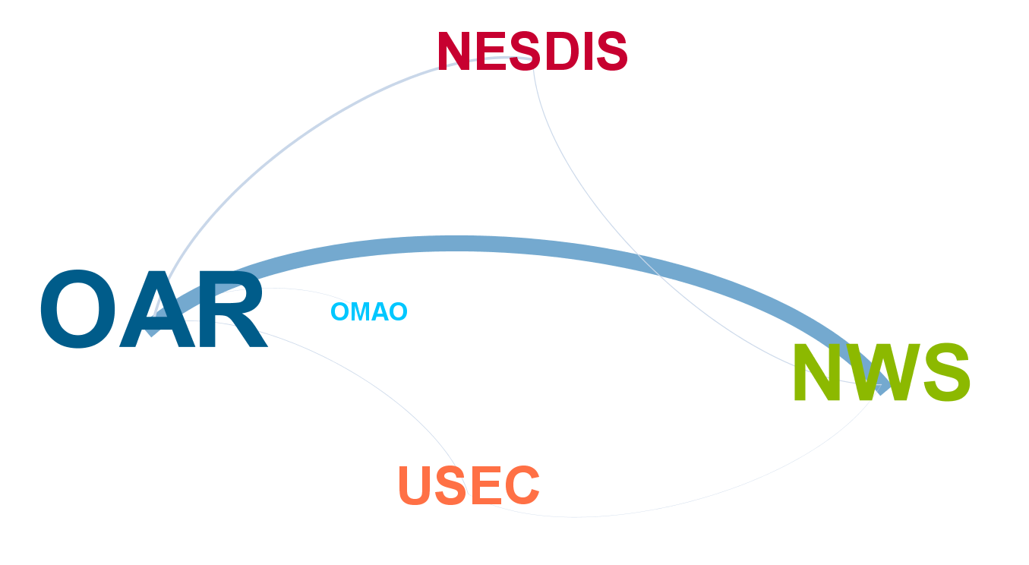
Figure 4: Network map illustrating coauthorship relationships between NSSL authors and authors in other NOAA line offices. NSSL authors most often collaborated on publications with staff from the National Weather Service (NWS), coauthoring 53 articles between 2016 and 2020.

Institutional affiliation | Number of occurrences
National Oceanic Atmospheric Admin* | 445
University Of Oklahoma System | 367
NASA | 38
NCAR | 36
Coop Inst Mesoscale Meteorol Studies | 35
University Of Colorado System | 27
United States Department Of Energy | 22
University Of Illinois System | 18
Colorado State University | 17
Pennsylvania Commonwealth System Of Higher Ed | 15
University System Of Maryland | 14
California Institute Of Technology | 12
University Of Wisconsin System | 12
Hebrew University Of Jerusalem | 11
University Of North Carolina | 11
Environment Climate Change Canada | 10
State University Of New York SUNY System | 10
Texas Tech University System | 10
Nanjing University | 9
North Carolina State University | 9
Pacific Northwest National Laboratory | 9
Purdue University | 9
Table 5. Top institutional affiliations of collaborating authors on NSSL articles 2016-2020.
*Includes NSSL authors

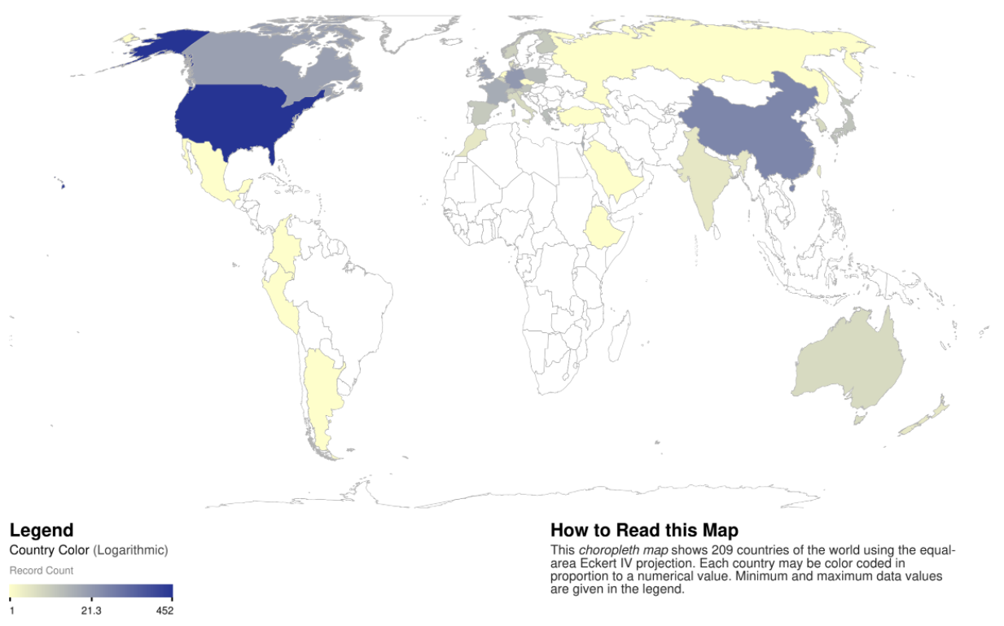
Figure 4. Geographic map illustrating NSSL’s international collaborations on articles published between 2016 and 2020.

Figure 5. Count of coauthoring organizations as sorted by type. NSSL authors coauthored articles affiliated with 152 organizations between 2016 and 2020.

IMPACT
This section analyzes the 3,503 publications citing 452 NSSL articles for insights into the value and impact of NSSL research.

Figure 6: Non-cumulative number of citations received by this set of NSSL articles between January 2016 and October 2021.
Figure 7: Distribution curve showing the citation counts of the 40 most highly cited NSSL articles between 2016 and 2020. The straight line indicates the H-Index threshold (slope: y = x). The intersect point of the two curves (33) is the H-Index of NSSL articles.

Figure 8: The 452 NSSL articles analyzed in this report have been cited in 516 distinct titles. The top fifteen titles are shown here.

Figure 9: The fifteen most common Web of Science research areas in which these NSSL articles were published in. Articles are assigned to subject categories by WoS based on the journal in which the article appeared. These subject categories are not mutually exclusive.

Figure 10: The 452 NSSL articles analyzed in this report have been cited by authors affiliated with more than 2,500 organizations. The top twenty of these organizations are shown here.
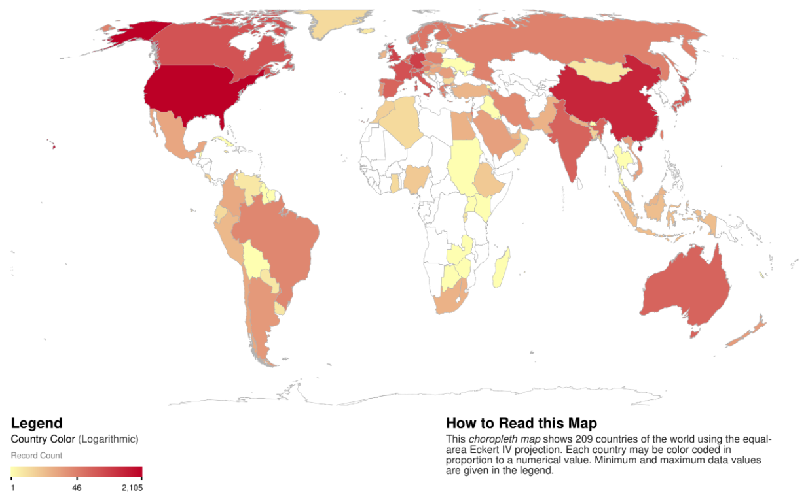
Figure 11: Geographic map illustrating international citations of NSSL articles published between 2016 and 2020.

APPENDIX 1: RESPONSIBLE USE OF BIBLIOMETRICS
When used alongside other evaluative measures, bibliometrics can be a useful tool for evaluating research. However, all bibliometric indicators have limitations and should not be used out of context or applied without a full understanding of their intended use. No single metric can provide a rounded overview of research performance so responsible use of metrics requires using multiple metrics and providing context for those metrics. It can be helpful to think of a bibliometric analysis as a story where each indicator is a plot point. Additionally, bibliometrics should not be used as the sole basis for decision-making or for evaluating the work of either an individual or group.
Some Pros & Cons of Bibliometrics
Pros
- Quantitative, objective and reproducible
- Easy to understand and easily updated
- Fully scalable - from individual- to country-level
Cons
- Datasets, particularly from standard databases like Web of Science (WOS), may represent only a portion of existing publications
- Most indicators are skewed and are vulnerable to manipulation by authors & publishers. H-index for example highly favors authors with longer careers.
- Indicators don’t necessarily mean what we think they mean (e.g. a high citation count may be the result of “negative” citations rather than an indicator of quality)
Further reading on the responsible use of bibliometrics:
Aksnes, D. W., L. Langfeldt, & P. Wouters. 2019. Citations, Citation Indicators, and Research Quality: An Overview of Basic Concepts and Theories. SAGE Open, 9. doi:10.1177/2158244019829575.
Barnes, C. 2017. The h-index debate: An introduction for librarians. The Journal of Academic Librarianship 43:487-494, doi:10.1016/j.acalib.2017.08.013.
Belter, C.W. 2015. Bibliometric indicators: Opportunities and limits. Journal of the Medical Library Association. 103(4):219-221. doi:10.3163/1536-5050.103.4.014.
Clarivate Analytics. 2020. InCites benchmarking & analytics: Responsible use of research metrics. http://clarivate.libguides.com/incites_ba/responsible-use. Accessed 12/16/2020.
Haustein, S., V. Lariviere. 2015. The use of bibliometrics for assessing research: Possibilities, limitations and adverse effects. In: Welpe IM, J. Wollersheim, S. Ringelhan, M. Osterloh, eds. Incentives and performance. Springer, Cham. Pg. 121–139. doi:10.1007/978-3-319-09785-5_8.
Hicks, D., P. Wouters, L. Waltman, S. de Rijcke and I. Rafois. 2015. Bibliometrics: The Leiden Manifesto for research metrics. Nature 520:420-531. doi:10.1038/520429a.
Pendlebury, D.A. 2010. White paper: Using bibliometrics in evaluating research. Thomson Reuters, Philadelphia, PA. https://lib.guides.umd.edu/ld.php?content_id=13278687.

APPENDIX 2: METHOD AND SOURCES
This report provides a bibliometric analysis of publications produced by the NOAA National Severe Storms Laboratory (NSSL) from January 2016 to December 30, 2020. For our data source, we used the NOAA Central Library’s database of all NOAA articles 2012 to present to extract a list of NSSL articles published during the review period of 2016-2020. Publications were identified by searching for NSSL and variations of NSSL in the authors stated affiliations. Search results were manually reviewed and verified for accuracy and assigned to line office and research labs based on the authors’ listing in the NOAA staff directory. Because we use the WoS analytical tools for our bibliometric analyses, NSSL publications that do not appear in WoS have been omitted from the data set. Bibliographic citations and citation data were downloaded from WoS and Clarivate InCites.
Although we have included publication and citation data through December 2020 in our data set, it is generally agreed that publications must be at least two years old for citation reporting to be meaningful. Therefore it should be noted that the citation data for the more recent publications is preliminary and is most likely not indicative of their eventual impact.
Publication and citation data were downloaded from Web of Science and InCites on October 8, 2021. Because of slight differences in indexing schedules and algorithms, citation data can vary slightly between WoS and InCites. The full publication list and data sets are from Sarah.Davis@noaa.gov

